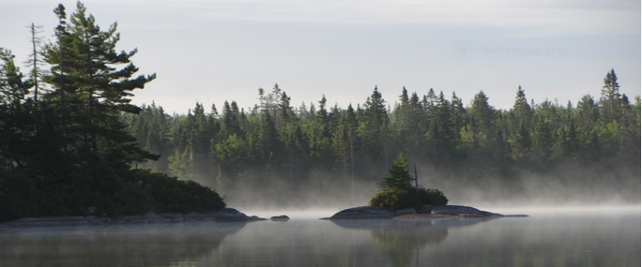

Woodens River Watershed Environmental Organization
Chair’s Report
AGM
March 30th 2017

Contents
Acknowledgements 3
Recalling the situation at AGM 2016 3
Sectoral Engagement: WRWEO’s work with like-minded groups 4
Management Agreement with Nova Scotia Environment 5
Renaming the second loop 6
CPTED Audit, Maintenance, & Issues related to the Parking Lot at 2890 St. Margaret’s Bay Road 7
NRET Interns 8
Summer Student Sharing 9
Volunteer Events: Trail Maintenance, Remediation, Engagement, Etc. 12
Parking Lot Clean-Up (April 23rd 2016) 12
Volunteer Information Session (July 5th 2016) 13
Trail-Build Day (October 1st 2016) 14
Trail Build Day (November 12th 2016) 15
Corrective Tree Pruning Workshop (December 4th 2016) 15
Small-Team Remediation Days & Visitor Engagement 16
Parking Lot Checks & User Engagement 17
Repainting Waymarkers (May & September 2016) 17
Improving Sight Lines in Parking Lot (July 6th 2016) 17
Posting Signs at Hubley Big Lake Portage (July 30th 2016) 17
Site Inspections for proposed LNT sites (August 6th 2016) 17
Designating LNT sites (August 21st 2016) 17
Disassembling illegal lean-to (August 21st 2016) 17
Remediation & Engagement (January 28th 2017) 18
Contracted Maintenance 19
Leave No Trace Educational Sites 20
Bluff Trail Stewardship Program (BTSP) 20
Volunteer Trail Steward Training (February 25th & March 18th 2017) 22
NSE Trail Inspection Report 23
Conclusion 24

Acknowledgements
I will begin this report with an acknowledgment that the Woodens River Watershed, The Bluff Wilderness Hiking Trail, and all of the efforts of the Woodens River Watershed Environmental Organization (WRWEO) exist on unceded and unsurrendered Mi’kmaw territory.
I wish to offer sincere thanks to those individuals who served as directors for WRWEO this year:
Ben Armstrong; Paul Berry (Treasurer); Diana Jeliazkova (Secretary) who resigned from the board in August 2016 when she moved to British Columbia; David Johnson; Tim McGee; Dave Patriquin; and, Rob Williams.
I offer particular thanks to the many WRWEO members, volunteers, and private donors who have given WRWEO and The Bluff Trail much needed support over this past year. Many individuals have donated their time and money to help establish the new Bluff Trail Stewardship Program (BTSP) in the hope that together we can reduce the human harms which damage both The Bluff Trail and the Five Bridge Lakes Wilderness Area.
I would also like to thank those elected officials, government employees, and community organization who have given their support to WRWEO and The Bluff Trail over the past year: Iain Rankin MLA, Timberlea-Prospect; Reg Rankin former City Councilor District 12; Richard Zurawski City Councilor District 12 Timberlea – Beechville – Clayton Park – Wedgewood; Heather Olivella, Regional Protected Area Coordinator, Central Region, NSE Protected Areas & Ecosystems Branch; Halifax Regional Trails Association; NS Department of Communities, Culture and Heritage; NS Trails Federation; Hike Nova Scotia; other members of the Five Bridge Lakes Wilderness Area Stewardship Coalition: Five Bridges Wilderness Heritage Trust; Safety Minded ATV Association; St. Margaret’s Bay Area Rails to Trails Association; BLT Trail Association; and especially St. Margaret’s Bay Stewardship Association with whom WRWEO has partnered to create The Bluff Trail Stewardship Program.

Recalling the situation at AGM 2016
Those members and friends of WRWEO who attended the Annual General Meeting in 2016 will recall the central focus of the meeting was a serious discussion of a crisis facing WRWEO and The Bluff Trail.
By 2015, ten years after construction of The Bluff Wilderness Hiking Trail was completed, WRWEO was aware of a significant increase in the number of severity of harmful human impacts on the trail. Reports of harmful human impacts were found in messages from trail users left in the trail ‘sign-in book’ such as:
• … lots of garbage around Paradise Cove (6 June 2015)
• … Too much new evidence of inappropriate camping :-( (12 June 2016)
• … Too much destruction due to uneducated people (7 July 2016)

A more thorough documentation of human harms came in the form of a presentation made to the WRWEO board of directors on 10 November 2015 by two skilled and respected trail users: Heather Davis and Wade McIsaac. Among the issues of concern raised in their presentation was evidence of:
• Garbage, toilet paper, and human waste
• Inappropriate and harmful camping practices
• Cutting and chopping of trees
• Fire pits on soft surfaces, damage to tree canopy
• Trail deterioration including widening and braiding

Also in November of 2015, WRWEO received a trail inspection prepared by Forest Resources Technician Amy Marsters, for Nova Scotia Environment dated 6 November 2015. The trail inspection documented a variety of problems on the trail including nearly twenty (20) fire pits scattered throughout the trail system: 5 on Pot Lake Loop; 8 on Mi’kmaw Hill Loop; 2 on Bluff Loop; and, 4 on Hay Marsh Loop.
It was clear that the trail was in serious need of attention and WRWEO was seeking a way to effectively address the increasing number of human harms present on the trail. However, it was also clear that WRWEO did not have a sufficiently large or adequately organized pool of volunteer labour to deal with these issues.
WRWEO sent a letter to Peter Labor, Director - and Heather Olivella, Central Regional Coordinator - Protected Areas and Ecosystems Branch Nova Scotia Environment. The letter was dated 30 November 2015 and was meant to “alert Protected Areas to [the] rapidly developing issues on The Bluff Wilderness Hiking Trail” and to acknowledge that WRWEO was “having difficulty addressing [these issues] effectively.”
WRWEO and NSE - Protected Areas and Ecosystems Branch began working together to identify solutions. WRWEO reached out to sister organizations for support and assistance, and also engaged its membership, through the last AGM, in a discussion about how to address these issues. Much of this report will focus on the endeavors undertaken by WRWEO, since the last AGM, to address these ongoing concerns.

Sectoral Engagement: WRWEO’s work with like-minded groups
In addition to working closely with Nova Scotia Environment – Protected Areas & Ecosystems Branch, WRWEO works with many other organizations and coalitions related to trails, wilderness areas, and environmental protection.
WRWEO is an original member of the Five Bridge Wilderness Area Stewardship Coalition. The Coalition groups including Five Bridge Wilderness Heritage Trust, Safety Minded ATV Association, St. Margaret’s Bay Stewardship Association, St. Margaret’s Bay Area Rails to Trails Association, BLT Trail Association and WRWEO have recently signed a service agreement with Five Bridges Wilderness Heritage Trust related to the Coalition members serving as an at-arms-length review committee for an exciting new Environmental Stewardship Grant Program that allows community members or groups to receive funding for projects that align with the Trust’s objectives. David Patriquin serves as the WRWEO representative on both the Stewardship Coalition and the Grant Review Committee.
WRWEO representatives attend meetings of the Council of Community Organizations (COCO) which helps to keep WRWEO informed and connected to many of our local sister organizations.
WRWEO continues to play an active role in the Halifax Regional Trails Association (HRTA). Paul Berry serves as the WRWEO representative at HRTA and has served on the HRTA executive as secretary for the past two years.
Along with many trail groups, wilderness groups, and environmental groups, WRWEO is a member of Our HRM Alliance. Alliance members are organizations from every corner of the municipality – rural, suburban, and the urban core. They include business associations, health organizations, environmental and community groups, and others. The membership is extremely diverse, growing, and committed to a more sustainable and liveable Halifax.
During this past year, several WRWEO directors and volunteers were present at the Public meeting to save Blue Mountain Birch Cove Lakes organized by the Ecology Action Centre (EAC) and held on Wednesday, June 29th 2016. At that meeting we all took the oath to become BMBC Rangers and to that end many of us participated in the letter writing campaign to save BMBC Lakes. Additionally, David Patriquin and Kimberly Berry attended the city council meetings held on July 26th and September 6th to stand in solidarity with others against development in the BMBC Lakes.
Most recently WRWEO has become a participating member of the Nova Scotia Healthy Forest Coalition. The HFC is an alliance of organizations and individuals united to raise public awareness of the critical state of our forests and the need for fundamental reform of forest policy. David Patriquin serves as the WRWEO representative on the HFC.

Management Agreement with Nova Scotia Environment
WRWEO has agreed to sign a Management Agreement with Nova Scotia Environment concerning the management of The Bluff Wilderness Hiking Trail. This Management Agreement will replace the Letter of Authority (LOA) WRWEO once held with the Nova Scotia Department of Natural Resources. The Management Agreement represents a significant commitment and reflects WRWEO’s enthusiasm for and confidence in the new Bluff Trail Stewardship Program which is designed to ensure the best possible stewardship practices on The Bluff Trail. (More information about The Bluff Trail Stewardship Program is described later in this report.)
It is important to note, the agreement was drafted by Nova Scotia Environment (NSE); however, there was a process of careful review and consideration, which included WRWEO seeking independent legal advice (ILA) from East Coast Environmental Law (ECELaw) and returning the proposed document to NSE with suggested changes. Following receipt of the finalized document from NSE, the WRWEO directors again reviewed the document, discussed several key clauses, and agreed at the board meeting on February 27th 2017 to sign the Management Agreement.

Renaming the second loop
At a board of directors meeting on February 9th 2016, it was agreed that WRWEO would approach the Mi’kmaw community to seek direction on the renaming of the second loop of The Bluff Wilderness Hiking Trail, formerly called “Indian Hill” Loop. The directors at WRWEO believe that the term “Indian” is considered by many to be a derogatory, archaic, and offensive word; therefore it was agreed to seek direction from the Mi’kmaq about a new name for the loop. On July 23rd 2016, the chair of WRWEO sent an email to Mike Lancaster, Wilderness Steward St. Margaret’s Bay Stewardship Association (SMBSA). The email read, in part:
While the dedication of The Bluff Wilderness Hiking Trail, written in 2005, acknowledged that the land had been preserved by the “First People”, none of the names used for the trail are Mi’kmaw names. In fact, the trail consists of four stacked loops which were all named more than a decade ago based on settler names used to describe the geography of the area. The names include: Pot Lake Loop, Indian Hill Loop, The Bluff Loop, and Hay Marsh Loop. The board of directors find the name of the second loop (Indian Hill) to be inappropriate given that the term “Indian” has long been considered a derogatory and offensive term. Because of this, WRWEO wishes to rename the second loop; however, we think it would be more appropriate to defer to members of the Mi’kmaw community for the selection of another name rather than continuing the pattern of settlers imposing names upon Mi’kmaw territory.
We hope that you may be able to introduce WRWEO to one or more members of the Mi’kmaw community who might be willing to advise WRWEO on how we might ask for the community’s guidance on the question of renaming the loop.
Following receipt of this request, Mike Lancaster contacted two individuals of Mi’kmaw descent, Ellen Hunt, former chair of the Mi’kmaq Burial Ground Research and Restoration Association and regular collaborator with the Micou’s Island Stewardship program, and Roger Lewis, Curator of Ethnology at the Nova Scotia Museum of Natural History. Roger Lewis in turn communicated with Mi’kmaq of Sipekne’katik (Shubenacadie) District, noting that the territory of K’jipuktuk (Halifax) is within the traditional territory of the Sipekne’katik District. He also communicated with Dr. Bernie Francis, Mi’kmaw Linguist and co-author of The Language of This Land, Mi’kma’ki. The consensus was that the name should simply be changed from “Indian Hill” to “Mi’kmaw Hill”.
WRWEO has now renamed the second loop of The Bluff Wilderness Hiking Trail the Mi’kmaw Hill Loop and has undertaken to update all electronic maps and will refer to the second loop as Mi’kmaw Hill in all social media posts and communications. WRWEO will work to make the appropriate changes to all future maps and printed materials; however, this process will take some time.
WRWEO would like to thank everyone who took time to consider this question and assist us in this matter. Particular thanks to Mike Lancaster, Ellen Hunt, Roger Lewis, Dr. Bernie Francis, and the Mi’kmaq of Sipekne’katik District who gave their time and thought to this process.

CPTED Audit, Maintenance, & Issues related to the Parking Lot at 2890 St. Margaret’s Bay Road
In April 2016, just after that last Annual General Meeting, it came to our attention that the business located next door to The Bluff Trail parking lot had suffered a break-in and theft. Surveillance video showed that the individuals responsible had used The Bluff Trail parking lot to gain access to the property. Following this incident, former city councilor Reg Rankin had arranged for Halifax Regional Police to conduct a Crime Prevention Through Environmental Design (CPTED) Audit. The CPTED Audit recommended several changes to the parking lot, some have already been implemented such as removing some of the vegetation along the fence on the west side to improve sight lines from St. Margaret’s Bay Road, the city has also removed some trees on the east side of the driveway as far as the property line would permit. A garbage can was returned to the parking lot in an attempt to reduce litter and the city intends to install power polls and lights in the parking lot. With financial support from Reg Rankin, WRWEO has also purchased a more effective surveillance camera which will be installed once the power polls are in place.
Although WRWEO and city staff had hoped to avoid the installation of power polls and lights by using the gate at the entrance of the parking lot to close the parking lot each night and open it each morning, the cost of employing a security company or contractor to lock and unlock the gate as required was prohibitive. Therefore it was agreed to increase artificial light and install an enhanced surveillance camera as recommended in the CPTED audit.
In addition to these changes, we also anticipate that the city will install a sign near the entrance to the parking lot. It is hoped that the addition of the city sign will help reduce the number of vehicles which drive past the entrance and turn around in the driveway of the neighboring business. This practice has been an on-going concern to our neighbors and we are hopeful that we might be able to curb the problem.
I would like to take this opportunity to repeat our request for all trail users and WRWEO friends to park on the west side of the parking lot, perpendicular to the fence. Parking in a perpendicular fashion on the west side of the lot allows for many more cars to fit in the parking lot and reducing the tendency for people to park on St. Margaret’s Bay Road which is an on-going concern for both our neighbors and the safety of everyone traveling on that area of the road.
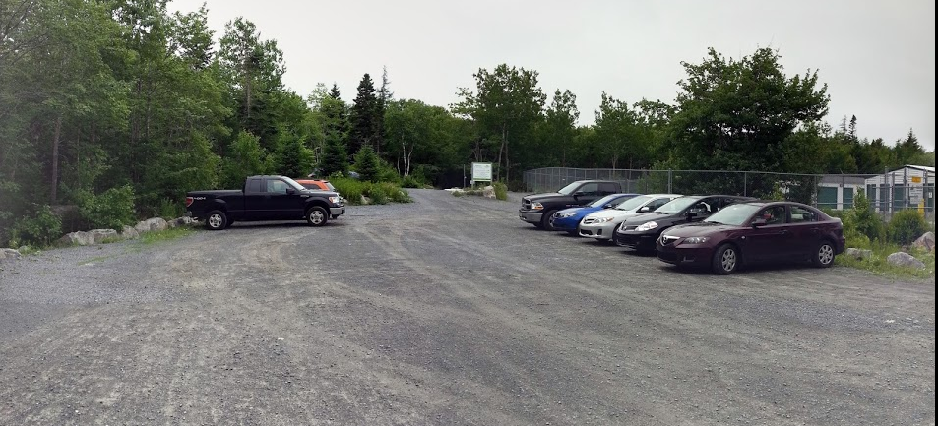
With financial assistance from Halifax secured through applications made through the Halifax Regional Trails Association (HRTA), WRWEO has contracted Atlantic Warf Builders to perform maintenance work on the parking lot including grading (to eliminate pot holes) and snow removal.

NRET Interns
In May 2016, WRWEO was able to partner with the St. Margaret’s Bay Stewardship Association (SMBSA) to provide a one-month one-the-job training placement for two students in the Natural Resources Environmental Technology (NRET) program at Nova Scotia Community College (NSCC). The two students, Kaitlyn Enders and Allyssa Poulin, were supervised by Mike Lancaster, the Stewardship Coordinator with the SMBSA. As part of the work placement, the NRET team spent two nights and three days documenting conditions on The Bluff Trail and created an orientation binder of information and materials to be used in the training of future volunteer trail stewards.
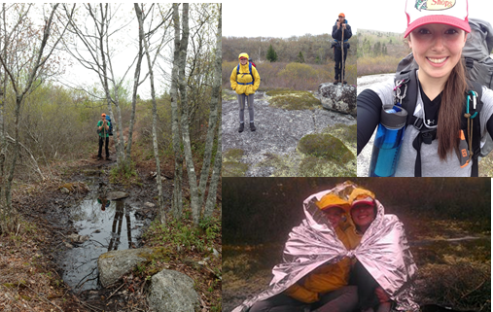
During their time on the trail the NRET team hiked approximately 43 km including back-tracking and covering canoe access points. They observed and documented flora and fauna species; assessed proposed Leave No Trace (LNT) sites and made recommendations for alternative LNT sites. They observed and documented evidence of human harms on the trail including several fires pits, and problematic camp sites. They took note of numerous problems with trail signage and way-markers. They observed many concerning examples of improperly pruned trees documented more than fifty areas on the trail with poor drainage in need of remediation with found-stone trail hardening. The NRET team reported their findings to the WRWEO directors at the board meeting on May 31st 2016 and helped set some priorities for the trail work in the months that followed.

Summer Student Sharing
Another collaborative endeavor involved several local organizations including: St. Margaret’s Bay Areas Rails to Trails; St. Margaret’s Bay Stewardship Association; Safety Minded ATV Association, Five Bridge Lakes Wilderness Heritage Trust, and WRWEO. These groups worked collectively to secure some funding through the Canada Summer Jobs program and contribute additional funds to ensure that two summer students received remote area wilderness first aid training and were employed on the various trails in the area as well as on Micous’s Island in the St Margaret’s Bay for approximately twelve weeks over the summer. Kaitlyn Enders and Allyssa Poulin were hired as the summer students and divided their time among the organizations involved.
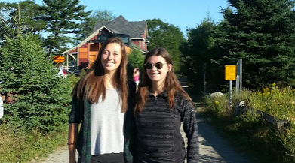
WRWEO benefited greatly from both the labour of the summer students and from the generosity of our sister organizations that contributed funds to the project and donated some of their hours to The Bluff Trail. Special thanks to both St. Margaret’s Bay Stewardship Association and the Five Bridge Lakes Wilderness Heritage Trust for donating some of their summer student hours to WRWEO.
During the time that Kaitlyn and Allyssa worked for WRWEO as summer students they spent a total of fourteen (14) days on The Bluff Trail engaging trail users and gathering information about trail use. Kaitlyn and Allyssa were on the trail from June 27th to June 30th; from July 4th to July 8th; and, from again from July 20th to July 24th. These dates included one Sunday and one Saturday; two each of Mondays, Tuesdays and Friday; and three Wednesday and Thursdays. During these days Kaitlyn and Allyssa engaged with a total of 402 trail users, and counted 44 dogs on the trail. The three highest single-day trail counts were 85 people on Sunday July 24th; 61 people on Monday June 27th; and, 44 people on Wednesday July 6th. On average over the fourteen days the summer students observed approximately 30 people per day.
In their encounters with the trail users, Kaitlyn and Allyssa asked individuals for the first part of their postal codes which offered WRWEO some information about where visitors to The Bluff Trail come from. During their days on the trail Kaitlyn and Allyssa collected postal code information from 178 people. Eleven of these individuals hailed from outside the province of Nova Scotia: three were from Ontario; two each from New Brunswick and the United States; one from Newfoundland and Labrador, one from Alberta, one from British Columbia, and one from the UK.
The remaining 167 visitors with postal codes from within Nova Scotia were distributed as follows: 33% from Chebucto Peninsula; 25% from Peninsula Halifax; 14% from Dartmouth; 13 % from Bedford / Clayton Park; 7% from Outside of HRM; 5% from Middle/Lower Sackville.
In addition to gathering data from the trail users, Kaitlyn and Allyssa also engaged visitors and offered information about the Protected Area status of the Five Bridge Wilderness Area, how visitors can reduce human harms on the trail by following Leave-No-Trace principals, and shared information about some of the valuable and vulnerable flora and fauna species found on the trail.
In addition to this on-trail work, Kaitlyn and Allyssa also contributed to WRWEO’s off-trail user engagement efforts by drafting Facebook posts which offered information about best practices when visiting the trail. They also gather photos and information for an information display board which was later featured at the Tantallon Public Library from September 9th to September 24th 2016.
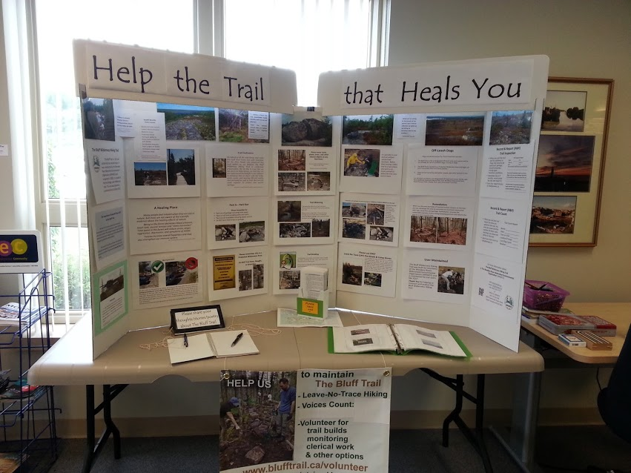
During Kaitlyn and Allyssa’s employment as summer students, the provincial government took extraordinary measures to reduce the risk of wildfires by placing a travel ban on woods in Nova Scotia. It was in the context of extremely dry conditions during August 2016, when there were a number of wildfires burning in the province, including fires at Maitland Bridge, Greenfield, and Seven Mile Lake, that the travel restrictions on woods in NS was announced on August 8th to become effected the following day. The travel ban was not lifted until August 17th. During that time, both St. Margaret’s Bay Stewardship Association and the Five Bridge Lakes Wilderness Heritage Trust donated some of their summer student hours to WRWEO and enabled us to offer support to our friends at BLT Rails to Trails Association as they attempted to maintain notices and flagging tape at the numerous intersections along the BLT trail. Because of the low compliance in some areas along the BLT trail, Kaitlyn and Allyssa spent their time traveling from one intersection to the next replacing the tape, reposting damaging notices, and talking to trail users about the importance of respecting the travel ban.
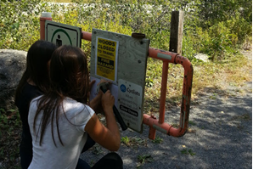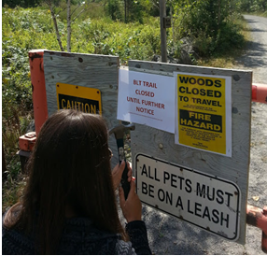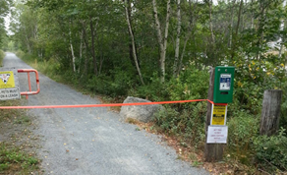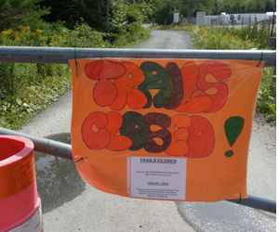

Volunteer Events: Trail Maintenance, Remediation, Engagement, Etc.
In addition to the NRET team and the summer student program, WRWEO coordinated a number of volunteer events to assist in the training of volunteers, maintenance and remediation on the trail, engagement of visitors, and some serious spring-cleaning in the parking lot.

Parking Lot Clean-Up (April 23rd 2016)
There were actually several parking lot clean-up days, beginning with Danielle Marchand’s one-woman job on April 23rd when she collected a full bag of litter. One two-woman job on May 14th when Kaitlyn and Allyssa volunteered 3 hours of their time to parking lot clean-up, and one “official” parking lot clean-up event on May 21st attended by three directors and one volunteer who collected two car loads of refuse which was carted to the waste management site in Prospect. Collectively these clean-up events represented approximately 25 hours of volunteer labour.
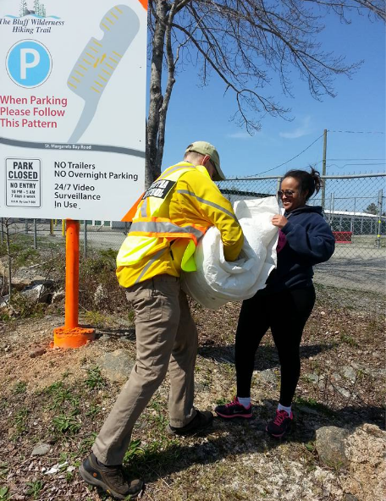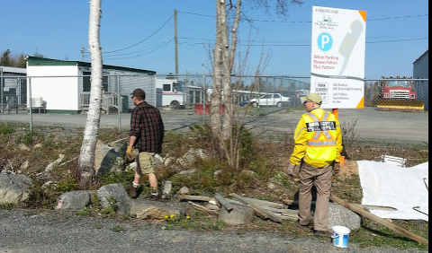

Volunteer Information Session (July 5th 2016)
WRWEO hosted a Volunteer Information Session at the Tantallon Public Library July 5th 2016 attended by four directors and seven volunteers. A variety of volunteer options were discussed, and a handout featuring a map, information about LNT practices, and a list of twelves ways to help The Bluff Trail was distributed. The volunteer information session represented approximately 12 hours of volunteer time dedicated to discussion and information sharing about the work needed on the trail.

Trail-Build Day (October 1st 2016)
A trail-build day on October 1st 2016 (Treaty Day) was attended by three directors and seven volunteers. Approximately 15 feet of trail hardening was completed on the first loop. During the day, one WRWEO director also engaged with approximately four dozen hikers offering some information about the work being done and suggesting ways for them help The Bluff Trail. The work completed on October 1st represented approximately 60 hours of volunteer labour.
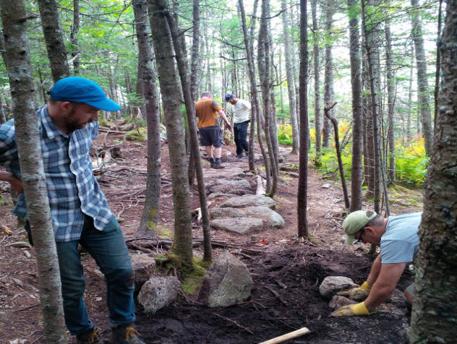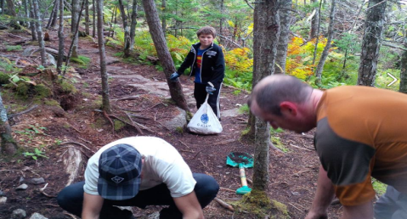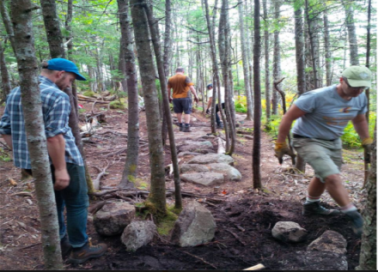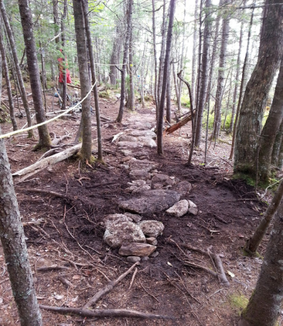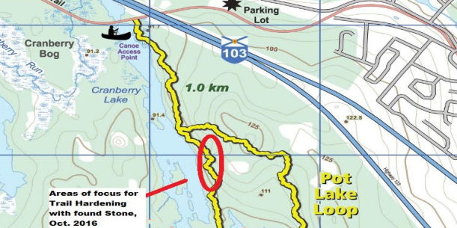

Trail Build Day (November 12th 2016)
A second trail-build event was held on November 12th 2016 and was attended by two directors and three volunteers. The group completed approximately 10 feet of trail hardening on the first loop just past the stream, but also addressed several areas of trail braiding mostly along the corridor leading to the fork junction of the bottom of the first loop. At these sites the team pulled fallen deadwood out of the brush to create natural barriers. During the time on the trail the work crew counted approximately 85 hikers and the work completed represented approximately 35 hours of labour.
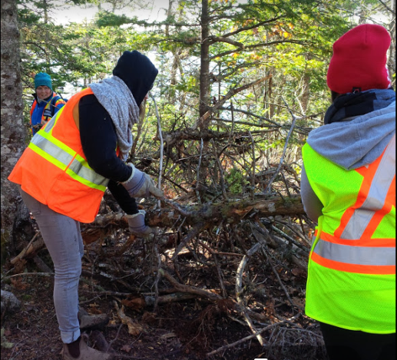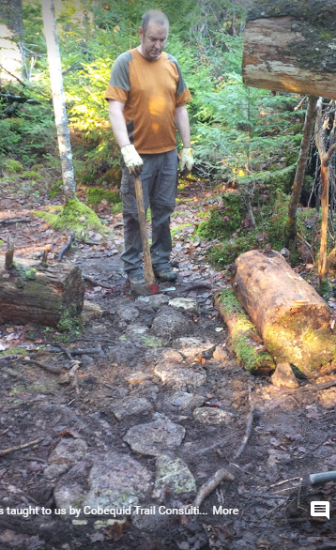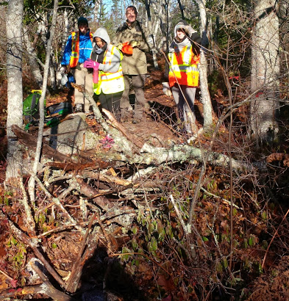

Corrective Tree Pruning Workshop (December 4th 2016)
On December 4th 2016, Mike Lancaster led a workshop on corrective tree pruning. The workshop was attended by fourteen people including three directors. In addition to instruction on proper tree pruning techniques, participants had an opportunity perform corrective pruning along some parts Pot Lake Loop. The group also took time to perform some remediation work and collect garbage along the corridor to the fork of the first loop. At one point in the day, Rob, Owen, and Isaac Williams demonstrated to the volunteers and passing hikers how to create a proper bowl fire. They also demonstrated how easy it is to avoid any risk of wildfire by packing out the ashes after the bowl fire had been extinguished. The volunteer training and trail work completed on December 4th represented approximately 56 hours of volunteer labour.
The events of this day included one injury. Shortly after noon, I fell on the far end of the whale’s back and broke my left ankle. Happily the fracture was not displaced and I was able to walk off the trail, albeit very slowly.
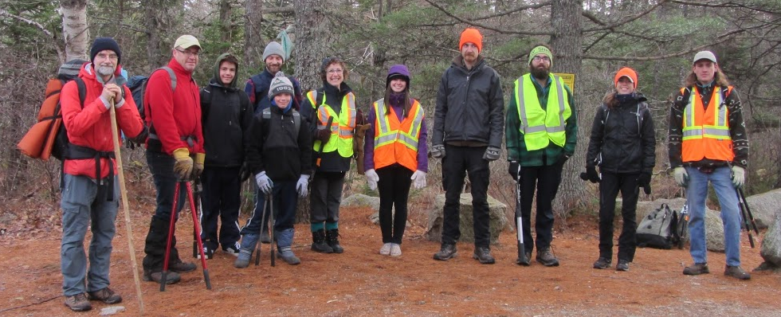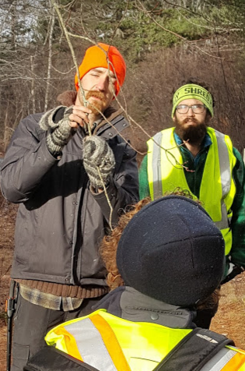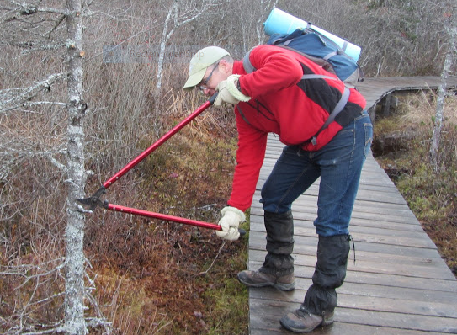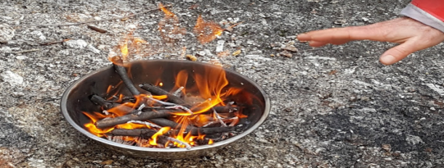

Small-Team Remediation Days & Visitor Engagement
In addition to these public volunteer events, there were several days when WRWEO directors and/or volunteers were engaging visitors in the parking lot, or performing remediation and/or user-engagement work on the trail.

Parking Lot Checks & User Engagement
As mentioned earlier in this report, there has been a long-standing problem of visitors parking improperly (in a parallel pattern) on the west side of the parking lot. This inefficient use of the parking lot space often results in other visitors being forced to park on St. Margaret’s Bay Road, which causes great concern to our neighbours who find cars parked near their driveways dangerously compromises their sight-lines as they attempt to enter and exit their properties. In an effort to keep tabs on the parking patterns WRWEO directors and volunteers visited the parking lot on at least forty separate days over the past year to document the number of vehicles and the parking patterns. On 16 different days a director or volunteer remained in the parking lot for an extended time (anywhere from 30 minutes and 2 hours) to encourage people to park perpendicular on the west side of the parking lot and/or distribute parking notices on cars. Many of these visits also involved collecting some amount of litter from the parking lot.

Repainting Waymarkers (May & September 2016)
In May, one of our volunteers repaired and repainted the waymarkers on Mi’kmaw Hill Loop (blue loop) and the Bluff Loop (red loop). In September, he repainted the way markers on Hay Marsh Loop (orange loop).

Improving Sight Lines in Parking Lot (July 6th 2016)
On July 6th 2016, one director cut the vegetation along the fence on the west side of the parking lot to clear sight-lines from the St. Margaret’s Bay Road, as recommended in the CPTED audit. Another director later cleared the cut vegetation from parking lot.

Posting Signs at Hubley Big Lake Portage (July 30th 2016)
On July 30th 2016, one director paddled Hubley Big Lake and replaced the “Protected Wilderness Area” sign that had been damaged by shotgun pellets and also placed a “no camping” sign at the same location.

Site Inspections for proposed LNT sites (August 6th 2016)
On August 6th 2016, two directors inspected four proposed LNT educational sites along the north side of Mi’kmaw Hill Loop, collected garbage from the trail and engaged with approximately two dozen hikers.

Designating LNT sites (August 21st 2016)
On August 21st 2016, two directors visited sites on Mi’kmaw Hill Loop and the Bluff Loop, remediating campfires, collecting garbage, and placing signage to officially designate the three LNT educational sites.

Disassembling illegal lean-to (August 21st 2016)
Also on August 21st 2016, one of WRWEO’s volunteers discovered and dismantled an illegal lean-to which had been constructed on Mi’kmaw Hill Loop.

Remediation & Engagement (January 28th 2017)
On January 28th 2017, Mike Lancaster led a small team of four including one director and two volunteers. The main project of the day was remediation work at a site on the second loop approaching Lower Marsh Lake where the illegal lean-to shelter had been constructed earlier during the summer. Jinbok Park, had taken the lean-to apart and carried out the plastic tarp used in its construction on August 21st 2016, but a considerable amount of wire remained attached to the discarded wood. The remediation team removed the remaining wire, dispersed the wood, and remediated a campfire site at the same location. Mike Lancaster continued hiking after the rest of the team was done for the day. He inspected other sites of concern and spent the night near the Middle Five Bride Lake off of the Hay Marsh Loop. On January 29th while hiking out, Mike encountered a team of Search & Rescue personnel attending to a hiker who had fallen and injured her ankle or leg and who could not stand to hike out. Mike stayed with group of emergency responders while the injured hiker was egressed by helicopter. To our knowledge, this was the third helicopter rescue on The Bluff Trail since the trail was constructed. Since this incident, arrangements have been made for WRWEO representatives to meet with NSE and Search & Rescue personnel to discuss egress options for the trail. The meeting is scheduled for April 13th 2017.
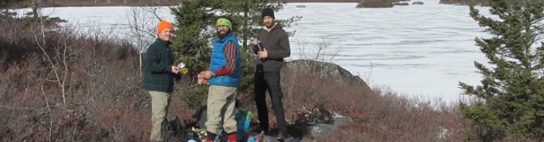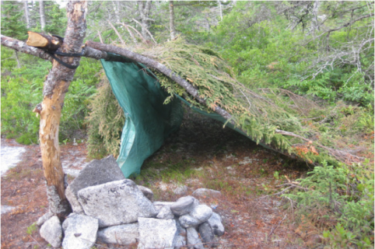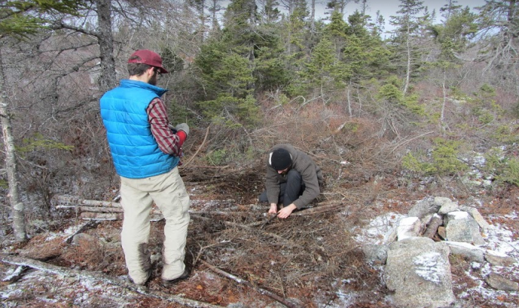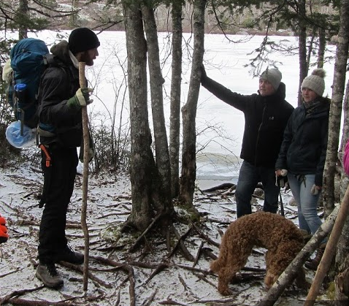

Contracted Maintenance
WRWEO receives funding from both Halifax, through Halifax Regional Trails Association (HRTA) maintenance grant applications and the Province of Nova Scotia, through Nova Scotia Department of Communities, Culture and Heritage for trail maintenance.
It has been the practice to brush cut along the first two loops and then the further two loops on alternating years. According to the established schedule, this year would have seen brush cutting along the Bluff and Hay Marsh Loops (loop 3 and loop 4). In consideration of both the noticeable degree of widening along many areas of the trail and also in response to the concerning number of wet areas observed by the NRET team, it was decided to make some change to the typical maintenance pattern. Paul consulted with one volunteer who frequently travels on the Bluff and Hay Marsh Loops and he confirmed that WRWEO could forgo brush cutting on the further loops this year. It was agreed to use a combination of volunteer and contracted labour to focus on found-stone hardening on the Pot Lake Loop this year. Cobequid Trails Consulting completed nearly 200 feet of stone hardening at various locations along the east side and southern tip of the Pot Lake Loop.
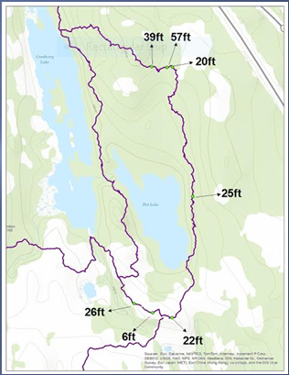 | 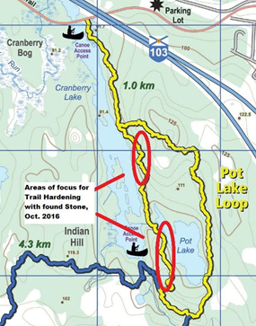
Cobequid Trails Consulting completed nearly 200 feet of stone hardening at various locations around the Pot Lake Loop | Volunteer trail hardening work focused on the west side of the Pot Lake Loop and covered approximately 25 feet in total and representing approximately 100 hours of volunteer labour.

In addition to the trail hardening work, WRWEO also contracted local arborist Mike Lancaster to perform corrective pruning along the trail. As mentioned earlier in this report, some corrective was done by volunteers during a training workshop on December 4th; additional corrective pruning was done by Mike Lancaster on the entire Pot Lake Loop and both the North and South sides (but not the cross section) of the Mi’kmaw Hill Loop. The work was performed on numerous days from November 2016 to January 2017.

Leave No Trace Educational Sites
One initiative undertaken this year to address the problem of increased human harms on the trail was to restrict camping activity on The Bluff Trail to specific locations. In August 2016, with the approval of NSE, WRWEO designated three “NSE Approved Leave No Trace (LNT) Educational Camping Sites.” By limiting camping to these designated sites it is hoped WRWEO might focus and minimize the harmful human impacts of camping on The Bluff Trail.
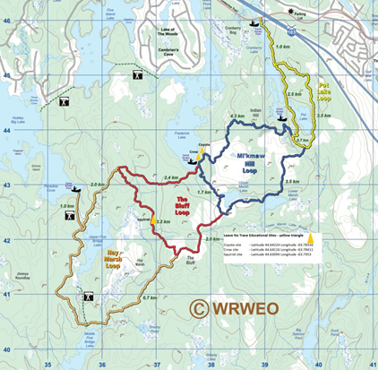 | Coyote/U’lukwej Site:  Latitude 44.64224  Longitude -63.78316  Crow/Ka’qaquj Site:  Latitude 44.64116  Longitude -63.78411  Squirrel/Atutu’wej Site:  Latitude 44.63094  Longitude -63.7953 | 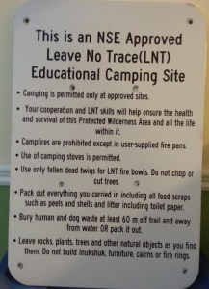

To learn more about the how WRWEO decided on this approach and for information about the process of identifying and selecting the LNT Educational Sites please see CAMP HERE: Curbing And Minimizing People-caused Harms to the Environment through Remediation and Education - A Proposal for “Designated LNT Educational Sites” for Camping on the Bluff Wilderness Hiking Trail. This report was submitted to Nova Scotia Environment - Protected Areas & Ecosystems Branch in January 2017 and can be found on the WRWEO website.

Bluff Trail Stewardship Program (BTSP)
Another initiative designed to address the problem of harmful human impacts on The Bluff Trail is the creation of The Bluff Trail Stewardship Program (BTSP). While WRWEO has made considerable efforts to improve the situation on the trail, as a small volunteer organization, WRWEO simply does not have the capacity to recruit, train, and coordinate a pool of volunteers of sufficient numbers to address the needs of this large trail and its challenging wilderness terrain.
The Bluff Trail Stewardship Program will be a collaborative effort between WRWEO and the St. Margaret's Bay Stewardship Association (SMBSA). SMBSA has already demonstrated success in the establishment of coordinated stewardship programs for Troop Island as well as eleven (11) public islands in St. Margaret’s Bay and is willing to share the experience, knowledge, and skills necessary to establish a sustainable stewardship program on The Bluff Wilderness Hiking Trail.
The proposed stewardship program will ideally include both a paid coordinator position and a paid assistant position. With these positions the program can offer sufficient worker-hours to recruit, train, and manage volunteers as well as ensure an appropriately trained and experienced presence on the trail to achieve the type of user engagement and educational approach required.
In order to finance this significant project, a fundraising request was sent to WRWEO members and friends on December 10th, 2016 and WRWEO raised $535 from Dec 10, 2016 to January 25, 2017, WRWEO also had a commitment for another $1300 (through monthly $50 instalments) for a total of $1,835 of pledged donations.
On January 25th 2017, WRWEO sent a second call to our membership to donate and announced that WRWEO had been approached by an anonymous supporter who had pledged to match any new donations (up to a total of $3 000.00) received before March 1st, 2017. The friends of The Bluff Trail responded with a further $1,450 in donations that will be matched by our anonymous supporter for a sub-total of $2,900 plus the $1,835 from the initial request for donations, for a grand total of $4,735.
In addition to the money raised from our members, WRWEO has received confirmation from Nova Scotia Environment – Protected Areas and Ecosystems Branch will contribute $10,000 to the BTSP.
A joint grant application from SMBSA and WRWEO to the Royal Bank of Canada – Blue Water Project, Community Action Grant secured a further $2500.
WRWEO and SMBSA have also submitted a grant application to Mountain Equipment Co-op Access & Activity Grants program.
Additionally, Five Bridges Wilderness Heritage Trust has recently announced a new Environmental Stewardship Grant Program that allows community members or groups to receive funding for projects that align with the Trust’s objectives. WRWEO and SMBSA have also submitted an application for an Environmental Stewardship Grant and we are confident that our Bluff Trail Stewardship Program is exactly the kind of initiative that the Trust is looking to support.
The amount of money we raise through WRWEO member donations and these grant applications will determine the program’s operational budget, and determine if the program can afford both the coordinator position and the assistant position and the number of hours the coordinator and possibly the assistant can be employed. The more money we are able to raise, the more comprehensive and effective the program can become.
WRWEO is deeply grateful for the support we have received for the BTSP and we are confident that we will be able to create a meaningful program which will have a positive effect on the stewardship of The Bluff Trail.

Volunteer Trail Steward Training (February 25th & March 18th 2017)
Mike Lancaster has led two training days for individuals interested in becoming volunteer trail stewards. These training sessions focus on engaging trail users and offering information about the rules which apply to The Bluff Trail. There was also information about the history of the trail and some of the vulnerable species that inhabit the area.
The first BTSP Volunteer Trail Stewards training day was held on February 25th 2017. It was led by Mike Lancaster, the Coordinator of the BTSP and attended by one board member and five volunteers.
The second training day was held on March 18th 2017. The training was led by Mike Lancaster and attended by eight volunteers. Two board members were on site at the beginning of the day to meet the volunteers, but did not participate in the training.
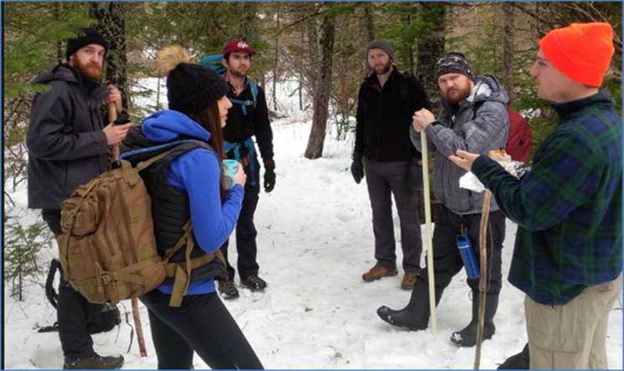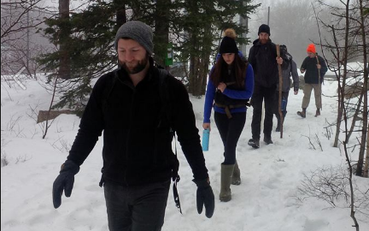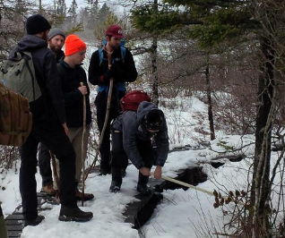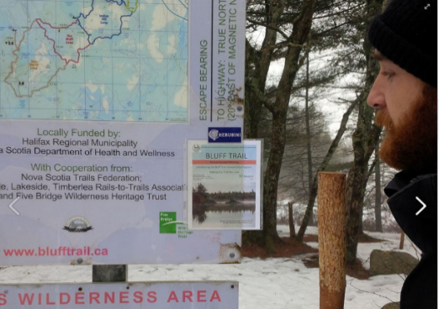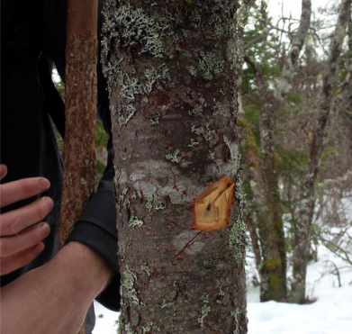

NSE Trail Inspection Report
Nova Scotia Natural Resources performs regular inspection of The Bluff Trail and submits its reports to WRWEO. The most recent report was dated December 30th 2016 and documents information gathered on four days of inspection: May 11th 2016; October 12th 2016; November 4th 2016; and, December 5th 2016.
The report documents maintenance work that WRWEO needs to undertake (specifically a couple of locations where large holes on the trail surface need to be filled); it records several signs that have been posted; and, notes fire pits, garbage, and other human harms on the trail.
The report notes that although the amount of garbage seems to be less than observed the previous year there is noticeable evidence of trail widening. There were also new fire pits along the trail although fewer than last year.
While last year’s report documented nearly twenty (20) fire pits scattered throughout the trail system (5 on Pot Lake Loop; 8 on Mi’kmaw Hill Loop; 2 on Bluff Loop; and, 4 on Hay Marsh Loop). This year’s report documented only six (6): 1 on Mi’kmaw Hill Loop; 1 on Bluff Loop; and, 4 on Hay Marsh Loop.

Conclusion
Since our AGM in 2016, WRWEO has made some significant progress toward addressing the stewardship needs of The Bluff Trail. WRWEO is particularly pleased about the creation of the new Bluff Trail Stewardship Program which is made possible through the generous support of WRWEO members, Nova Scotia Environment – Protected Areas & Ecosystems Branch, Royal Bank of Canada – Blue Water Project, Community Action Grant, and our partnership with St. Margaret’s Bay Stewardship Association. WRWEO hopes that this new Bluff Trail Stewardship Program will grow into a strong, sustainable, and comprehensive program sufficient to address the needs of The Bluff Trail.

Respectfully submitted by
Kimberly Berry - Chair, WRWEO
K'jipuktuk /Halifax - March 2017

